Given the root of a binary tree, imagine yourself standing on the **right side** of it, return *the values of the nodes you can see ordered from top to bottom*.

**Example 1:**

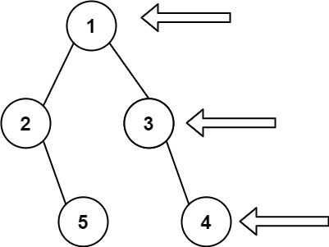

**Input:** root = [1,2,3,null,5,null,4]

**Output:** [1,3,4]

**Example 2:**

**Input:** root = [1,null,3]

**Output:** [1,3]

**Example 3:**

**Input:** root = []

**Output:** []

**Constraints:**

* The number of nodes in the tree is in the range [0, 100].
* -100 <= Node.val <= 100